Accessibility Conformance Report
Student Name: Evlin Varghese
Module: 5COM2002 – Accessibility and Usability
Website: Personal Profile Site (HTML/CSS/JS based)

Introduction
This report outlines the accessibility testing and improvements made to the personal profile website using the WAVE Evaluation Tool. The site was tested for WCAG 2.1 Level AA compliance using only the WAVE browser extension, as required by the assignment brief.

Test 1 – Mid-Development WAVE Conformance Test
The first test was conducted after the initial structure and styling of the website was implemented. The following screenshots demonstrate that the site initially had 0 accessibility errors and 0 contrast issues, but improvements in structure and labeling were still to be finalized.

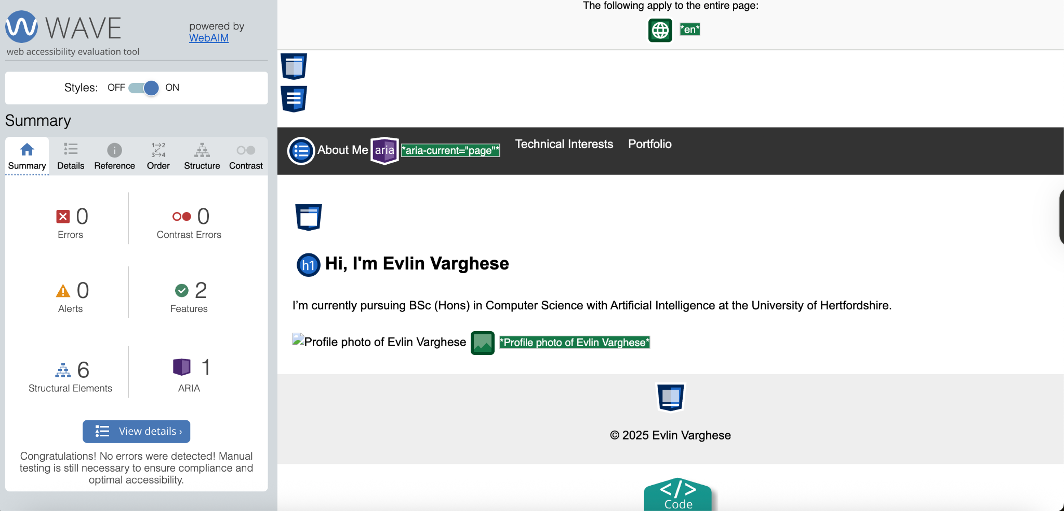
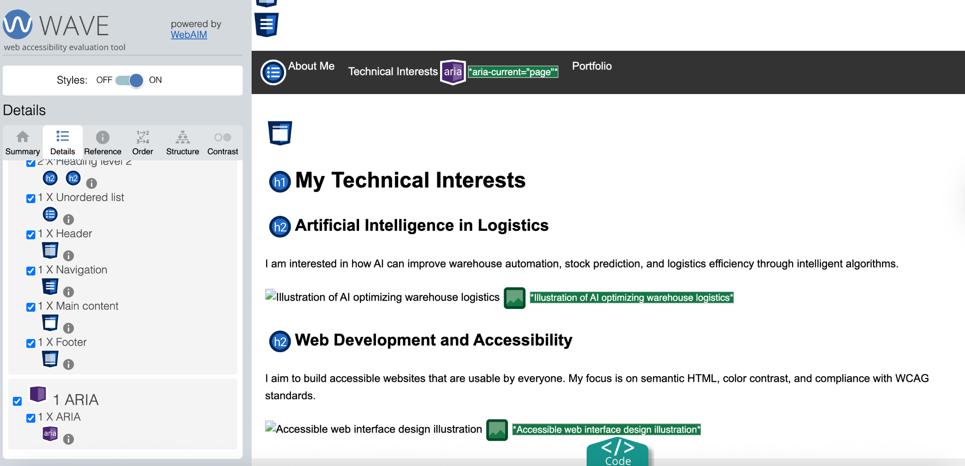
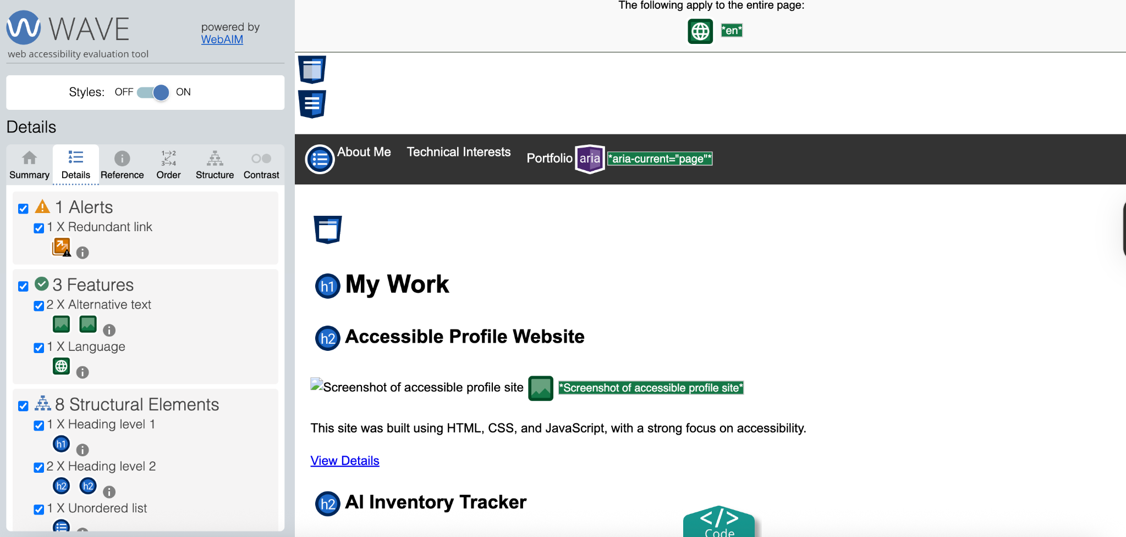

Corrections and Improvements Made
- Ensured proper heading order and use of <h1>, <h2> where needed
- Added `alt` attributes to all images with clear descriptions
- Removed any redundant links
- Separated decorative vs informative images and confirmed roles
- Used `aria-current='page'` where needed for navigation clarity
- Improved keyboard focus visibility and tab order

Test 2 – Final WAVE Conformance Test
The final test will be completed after all accessibility and usability improvements have been made. Another set of screenshots will be included here showing 0 errors and full WCAG 2.1 AA compliance.

Conclusion
The current state of the site passes all automated checks for WCAG 2.1 AA using the WAVE tool, and all major structural and label-based accessibility issues were addressed. Manual testing (keyboard-only navigation, ARIA testing) has also been considered during development.

Final WAVE Conformance Test
The final WAVE test was conducted after all pages were completed with semantic structure, styled images, accessible text, and correct use of navigation labels and ARIA attributes. All pages returned 0 accessibility and contrast errors, passing WCAG 2.1 Level AA compliance.
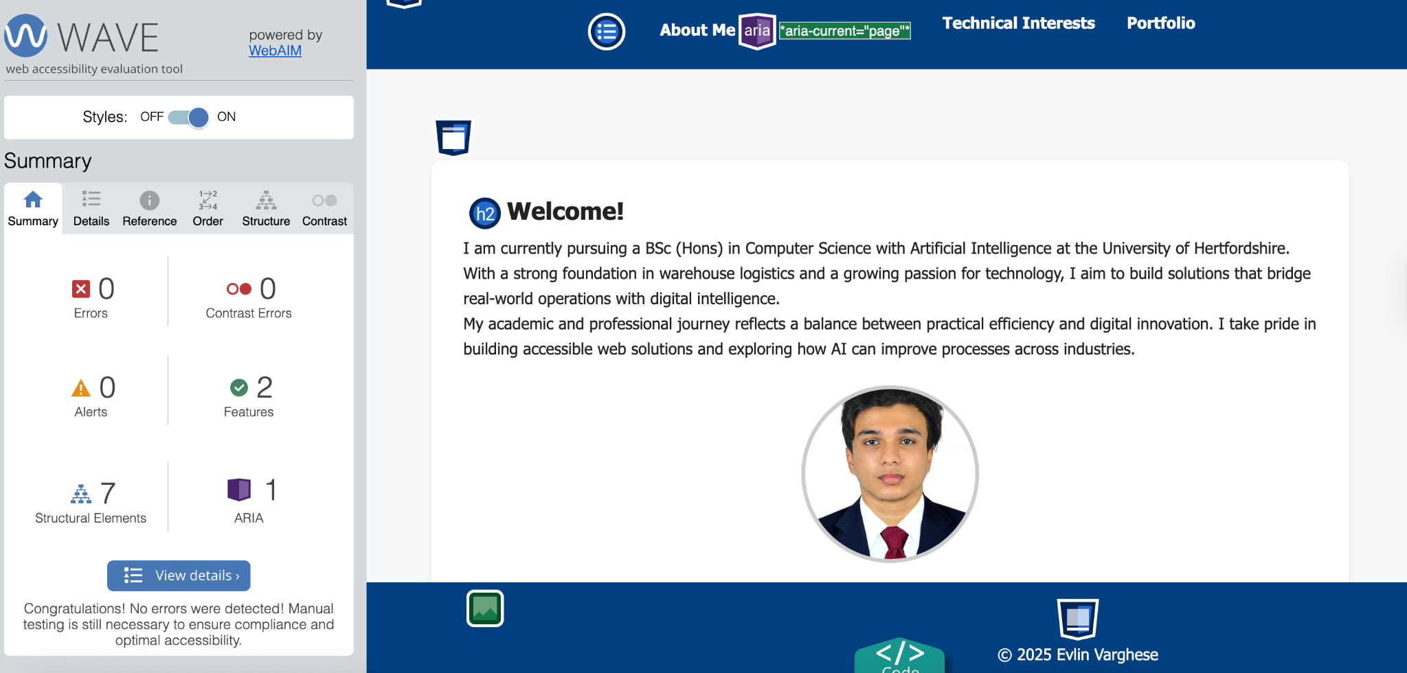
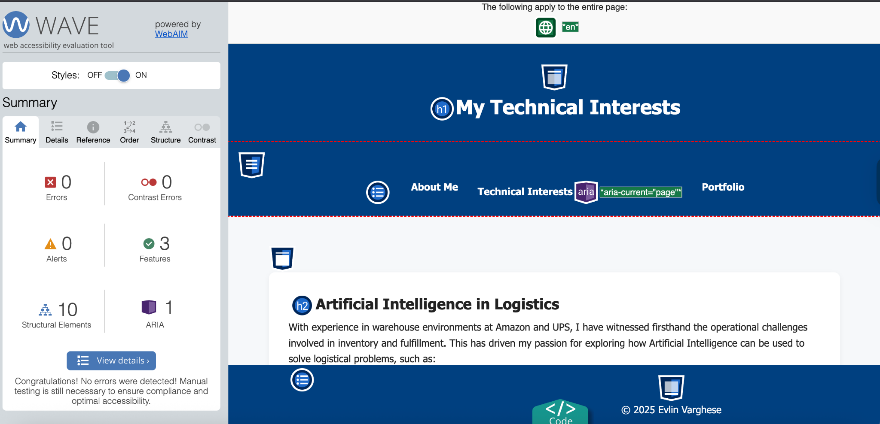
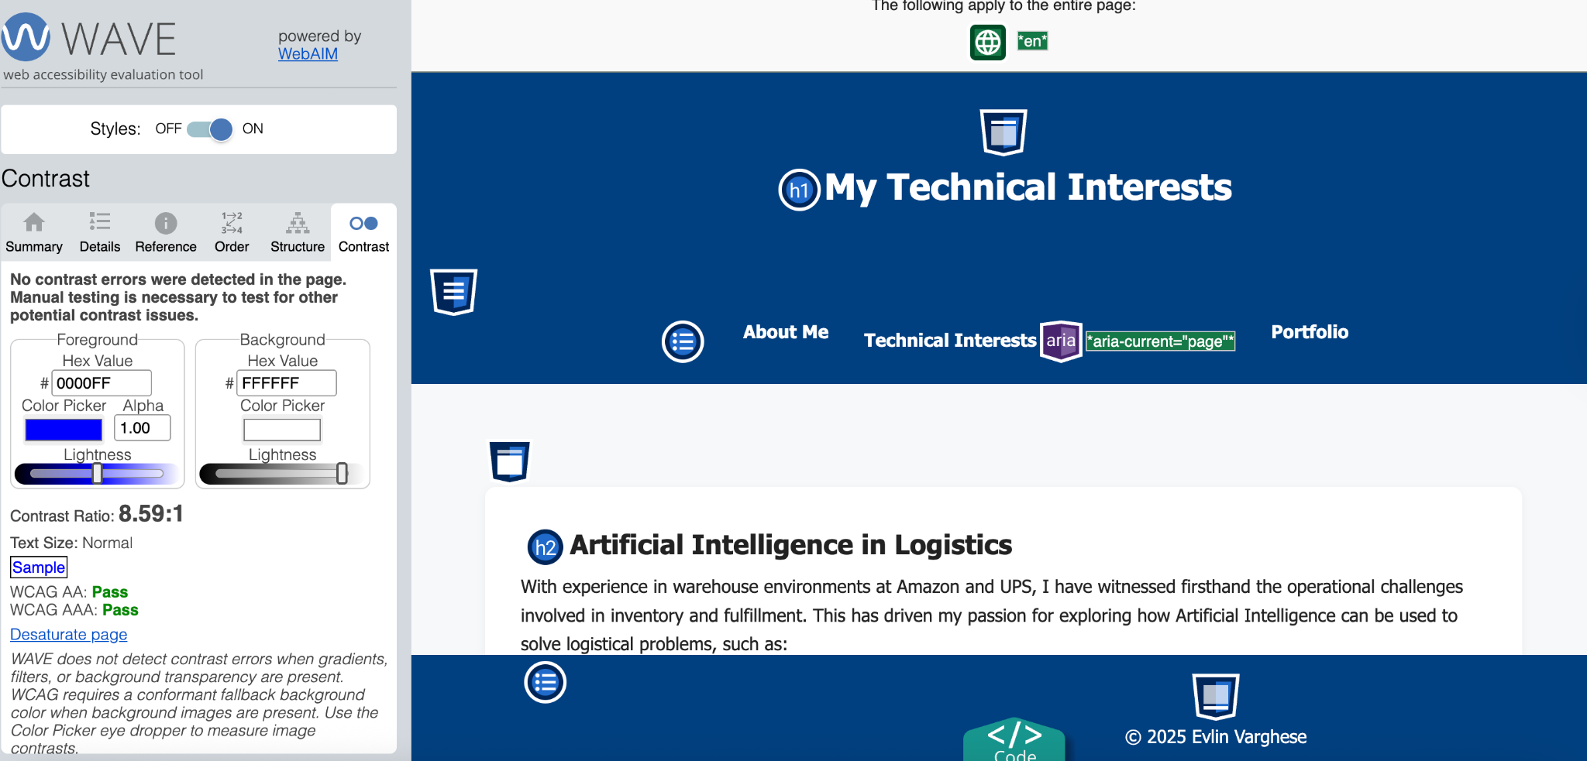
The site now meets accessibility best practices and has been tested across all pages, demonstrating a consistent, usable, and inclusive design.

